CHANGING THE SUBJECT OF A FORMULA
Pearson Edexcel - Tuesday 19 May 2020 - Paper 1 (Non-Calculator) Foundation Tier

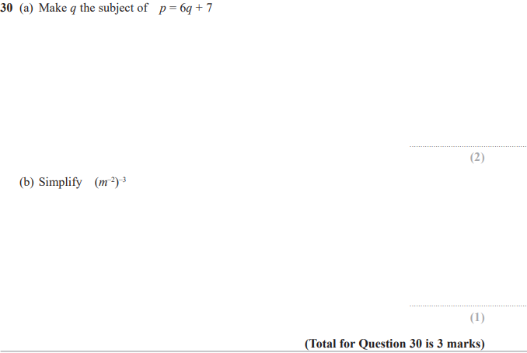

Pearson Edexcel - Tuesday 11 June 2019 - Paper 3 (Calculator) Foundation Tier

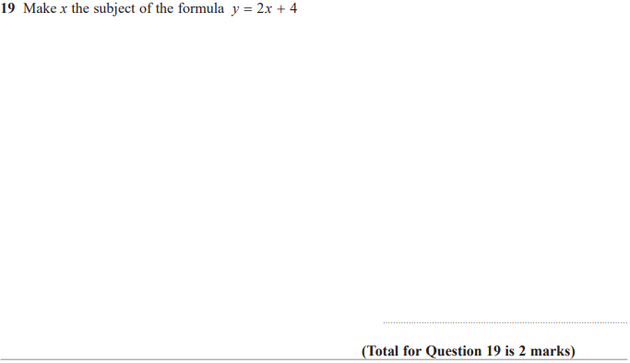

Pearson Edexcel - Tuesday 6 November 2018 - Paper 1 (Non-Calculator) Foundation Tier

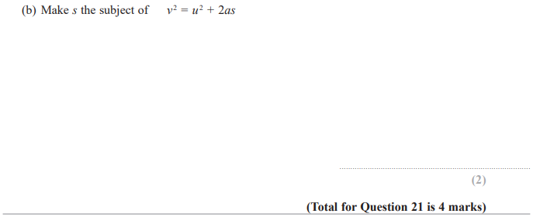

Pearson Edexcel - Tuesday 12 June 2018 - Paper 3 (Calculator) Foundation Tier

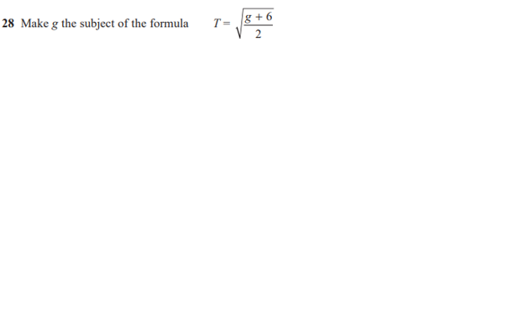

Pearson Edexcel – Specimen 2 - Paper 3 (Calculator) Foundation Tier

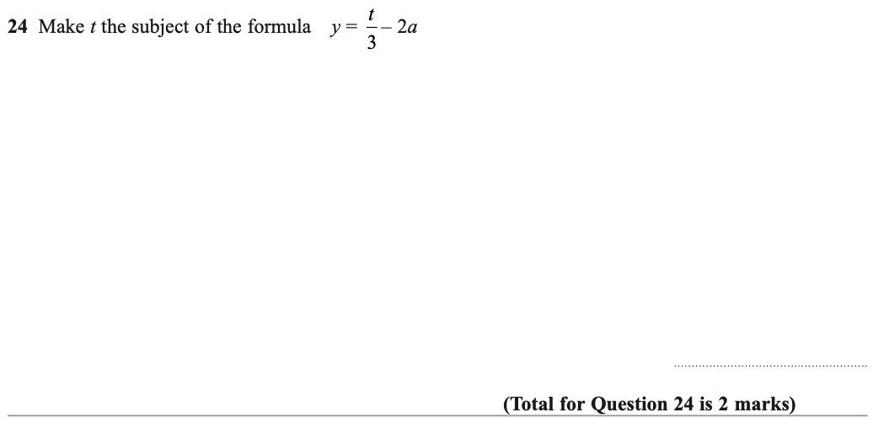

Pearson Edexcel – Specimen 1 - Paper 2 (Calculator) Foundation Tier

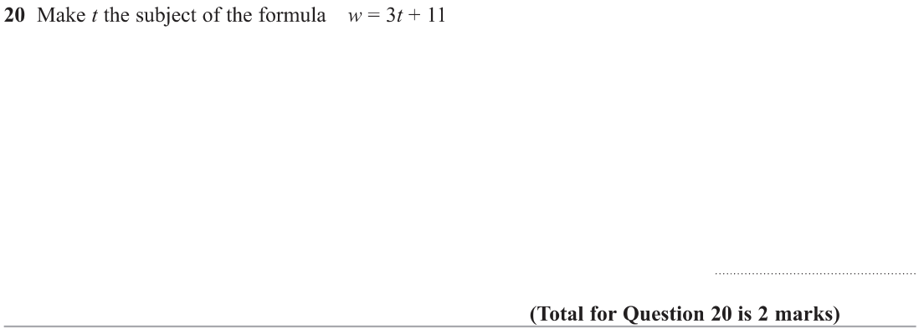

OCR Thursday 8 November 2018 – Morning (Non-Calculator) Foundation Tier
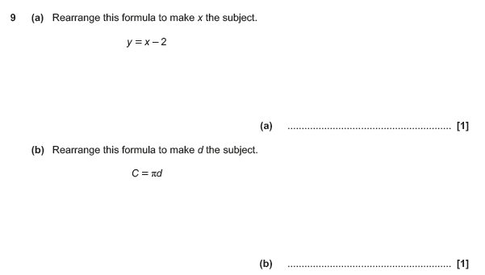

Pearson Edexcel –Sample Papers - Paper 2 (Calculator) Foundation Tier

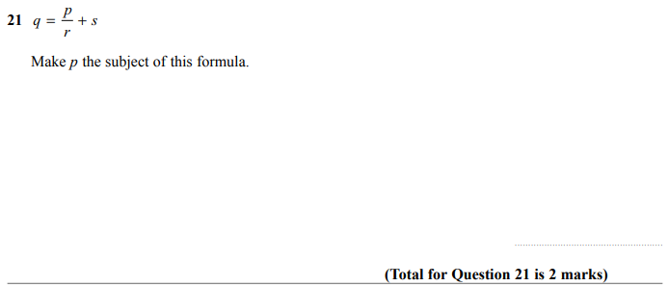

OCR Thursday 8 June 2017 – Morning (Non - Calculator) Foundation Tier

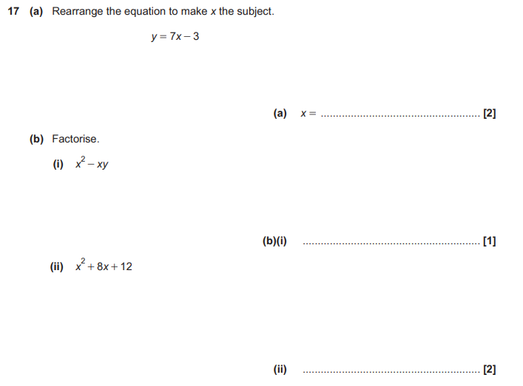

AQA Tuesday 19 May 2020 – Morning (Non-Calculator) Foundation Tier

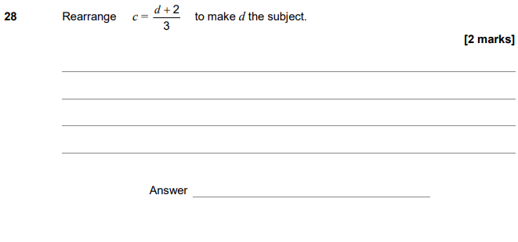
AQA Tuesday 21 May 2019 – Morning (Non-Calculator) Foundation Tier

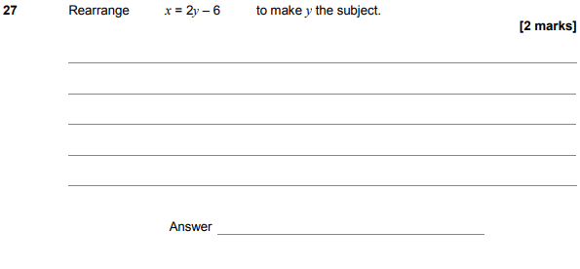

AQA Tuesday 12 June 2018 – Morning (Calculator) Foundation Tier

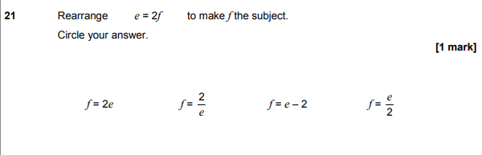
AQA Wednesday 8 November 2017 – Morning (Calculator) Foundation Tier

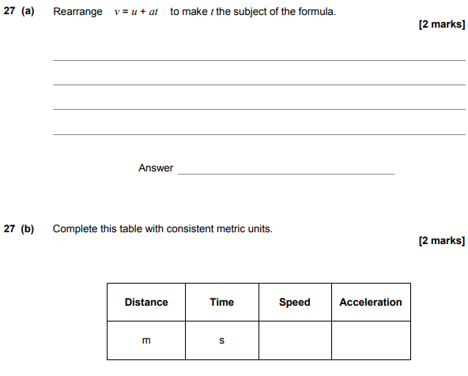

AQA Thursday 8 June 2017– Morning (Calculator) Foundation Tier

